Title Of The Abstract Written In Capitalize Each Word (14 pt, Times New Roman, Bold)

FIRST AUTHOR¹, SECOND AUTHOR², THIRD AUTHOR³*(14 pt, Times New Roman, Bold)

Abstract: Abstracts must be prepared in English and should consist of 200–300 words written in a single paragraph. The abstract should be clearly structured to include the aim(s) of the study, methodology, main findings, and conclusions. Tables, figures, and references must not be included in the abstract section. The manuscript should be prepared using Times New Roman font with 1.0 line spacing. The title and author information should be formatted in 14-point font, while all other sections—including the abstract text, keywords, author affiliations, and e-mail address—should be written in 10-point font. Keywords should be provided in accordance with the format shown in the sample abstract. A minimum of three (3) and a maximum of six (6) keywords must be included. Abstracts that do not comply with the above formatting and content guidelines will not be considered for review.

Keywords: keyword1, keyword2, keyword3, keyword4, keyword5.

¹ Address: University, Faculty, Department, City, Country
² Address: University, Faculty, Department, City, Country
³ Address: University, Faculty, Department, City, Country

*Corresponding author: e-mail@address.com

1. INTRODUCTION

Manuscripts must be structured to include the following sections: Introduction, Methods, Results, Conclusion, and References.

The entire main text must be prepared using Times New Roman font, with single line spacing (1.0) and a font size of 10 pt. Paragraph spacing should be created only by leaving a single blank line using the Enter key; no additional spacing before or after paragraphs should be applied. The text must be justified on both sides. Only section headings may be formatted in bold.

All tables and figures must be left-aligned. Table titles should be placed above the tables, while figure captions should be placed below the figures. Tables and figures must be numbered consecutively using Arabic numerals only (e.g., Table 2, Figure 3). Alternative numbering formats such as Figure 1.2 or Table 2.3 must not be used. Table and figure titles should not be written in bold. Authors are encouraged to use the provided template document.

The Acknowledgment section may be omitted if not required.

The sections titled Ethics Committee Approval, Author Contributions, Conflict of Interest, and Funding must not be deleted and must be fully completed.

All in-text citations and the reference list must strictly comply with the APA 7th edition referencing style.

The total length of the manuscript must not exceed 12 pages.

Manuscripts that do not comply with these guidelines will not be accepted for evaluation.

2. MATERIAL AND METHOD

Manuscripts must be structured to include the following sections: Introduction, Methods, Results, Conclusion, and References.

The entire main text must be prepared using Times New Roman font, with single line spacing (1.0) and a font size of 10 pt. Paragraph spacing should be created only by leaving a single blank line using the Enter key; no additional spacing before or after paragraphs should be applied. The text must be justified on both sides. Only section headings may be formatted in bold.

All tables and figures must be left-aligned. Table titles should be placed above the tables, while figure captions should be placed below the figures. Tables and figures must be numbered consecutively using Arabic numerals only (e.g., Table 2, Figure 3). Alternative numbering formats such as Figure 1.2 or Table 2.3 must not be used. Table and figure titles should not be written in bold. Authors are encouraged to use the provided template document.

The Acknowledgment section may be omitted if not required.

The sections titled Ethics Committee Approval, Author Contributions, Conflict of Interest, and Funding must not be deleted and must be fully completed.

All in-text citations and the reference list must strictly comply with the APA 7th edition referencing style.

The total length of the manuscript must not exceed 12 pages.

Manuscripts that do not comply with these guidelines will not be accepted for evaluation.

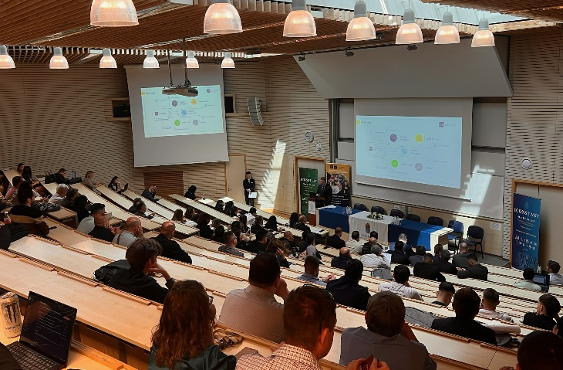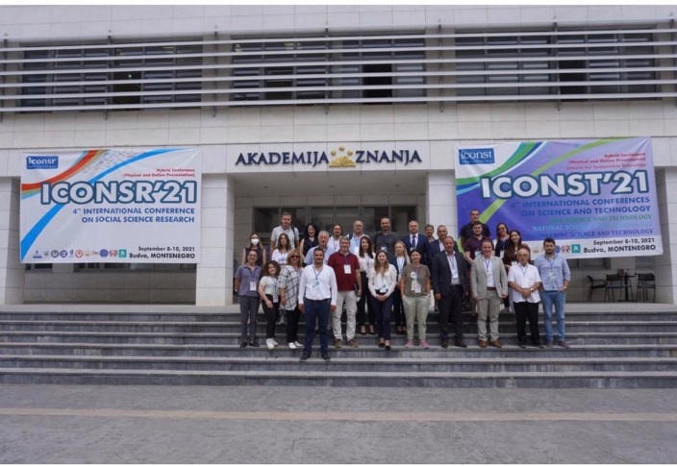

Figure 1. Experimental setup

Table 1. The technical specifications of test engine

Parameters | Specification | Parameters | Specification

3. RESULTS

Manuscripts must be structured to include the following sections: Introduction, Methods, Results, Conclusion, and References.

The entire main text must be prepared using Times New Roman font, with single line spacing (1.0) and a font size of 10 pt. Paragraph spacing should be created only by leaving a single blank line using the Enter key; no additional spacing before or after paragraphs should be applied. The text must be justified on both sides. Only section headings may be formatted in bold.

All tables and figures must be left-aligned. Table titles should be placed above the tables, while figure captions should be placed below the figures. Tables and figures must be numbered consecutively using Arabic numerals only (e.g., Table 2, Figure 3). Alternative numbering formats such as Figure 1.2 or Table 2.3 must not be used. Table and figure titles should not be written in bold. Authors are encouraged to use the provided template document.

The Acknowledgment section may be omitted if not required.

The sections titled Ethics Committee Approval, Author Contributions, Conflict of Interest, and Funding must not be deleted and must be fully completed.

All in-text citations and the reference list must strictly comply with the APA 7th edition referencing style.

The total length of the manuscript must not exceed 12 pages.

Manuscripts that do not comply with these guidelines will not be accepted for evaluation.

4. DISCUSSION AND CONCLUSIONS

Manuscripts must be structured to include the following sections: Introduction, Methods, Results, Conclusion, and References.

The entire main text must be prepared using Times New Roman font, with single line spacing (1.0) and a font size of 10 pt. Paragraph spacing should be created only by leaving a single blank line using the Enter key; no additional spacing before or after paragraphs should be applied. The text must be justified on both sides. Only section headings may be formatted in bold.

All tables and figures must be left-aligned. Table titles should be placed above the tables, while figure captions should be placed below the figures. Tables and figures must be numbered consecutively using Arabic numerals only (e.g., Table 2, Figure 3). Alternative numbering formats such as Figure 1.2 or Table 2.3 must not be used. Table and figure titles should not be written in bold. Authors are encouraged to use the provided template document.

The Acknowledgment section may be omitted if not required.

The sections titled Ethics Committee Approval, Author Contributions, Conflict of Interest, and Funding must not be deleted and must be fully completed.

All in-text citations and the reference list must strictly comply with the APA 7th edition referencing style.

The total length of the manuscript must not exceed 12 pages.

Manuscripts that do not comply with these guidelines will not be accepted for evaluation.

Acknowledgment
This study was supported by the Scientific Research………

Ethics Committee Approval
N/A

Author Contributions
All authors have read and agreed to the published version of manuscript.

Conflict of Interest
The authors have no conflicts of interest to declare.

Funding
This study was financial supported by the Scientific Research Projects……….

REFERENCES

1. Metin İçi Atıf (In-text Citation)
Tek Yazarlı
- Parantez içinde:
(Smith, 2020)
- Cümle içinde:
Smith (2020) stated that …
İki Yazarlı
- Parantez içinde:
(Smith & Johnson, 2021)
- Cümle içinde:
Smith and Johnson (2021) reported that …
Üç ve Daha Fazla Yazarlı
- İlk atıftan itibaren:
(Smith et al., 2022)
Doğrudan Alıntı
- Sayfa numarası ile:
(Smith, 2020, p. 45)

2. Kaynakça (References) Örnekleri
📘 Kitap
Format:
Author, A. A. (Year). Title of the book. Publisher.
Örnek:
Creswell, J. W. (2014). Research design: Qualitative, quantitative, and mixed methods approaches. SAGE Publications.

📗 Editörlü Kitap Bölümü
Format:
Author, A. A. (Year). Title of chapter. In E. E. Editor (Ed.), Title of the book (pp. xx–xx). Publisher.
Örnek:
Yin, R. K. (2018). Case study research and applications. In J. W. Creswell (Ed.), Qualitative inquiry and research design (pp. 235–256). SAGE Publications.

📄 Dergi Makalesi
Format:
Author, A. A., Author, B. B., & Author, C. C. (Year). Title of the article. Title of the Journal, Volume(Issue), xx–xx. https://doi.org/xxxxx
Örnek:
Porter, M. E., & Kramer, M. R. (2011). Creating shared value. Harvard Business Review, 89(1–2), 62–77.

🌐 Online Makale / Web Kaynağı
Format:
Author, A. A. (Year). Title of the page. Website Name. URL
Örnek:
World Health Organization. (2020). WHO guidelines on physical activity and sedentary behaviour. https://www.who.int

🎓 Tez / Disertasyon
Format:
Author, A. A. (Year). Title of the thesis (Master’s thesis/Doctoral dissertation). University Name.
Örnek:
Kaya, M. (2021). Sustainable tourism development in rural areas (Doctoral dissertation). Ankara University.

